MODULE 4 – INTRODUCTION TO DBMS

LAB EXERCISES

13. Transaction Control Language – TCL
Lab 1.
Use COMMIT after inserting multiple records into the books table, then mark another insertion and perform a ROLLBACK.
Ans.
1. INSERT INTO books (book_id, title, author, publisher, year_of_publication, price) VALUES
(6, 'database system', 'naveen', 'paerson', 2016, 150), (7, 'maths', 'kapil', 'dave', 2018, 90);
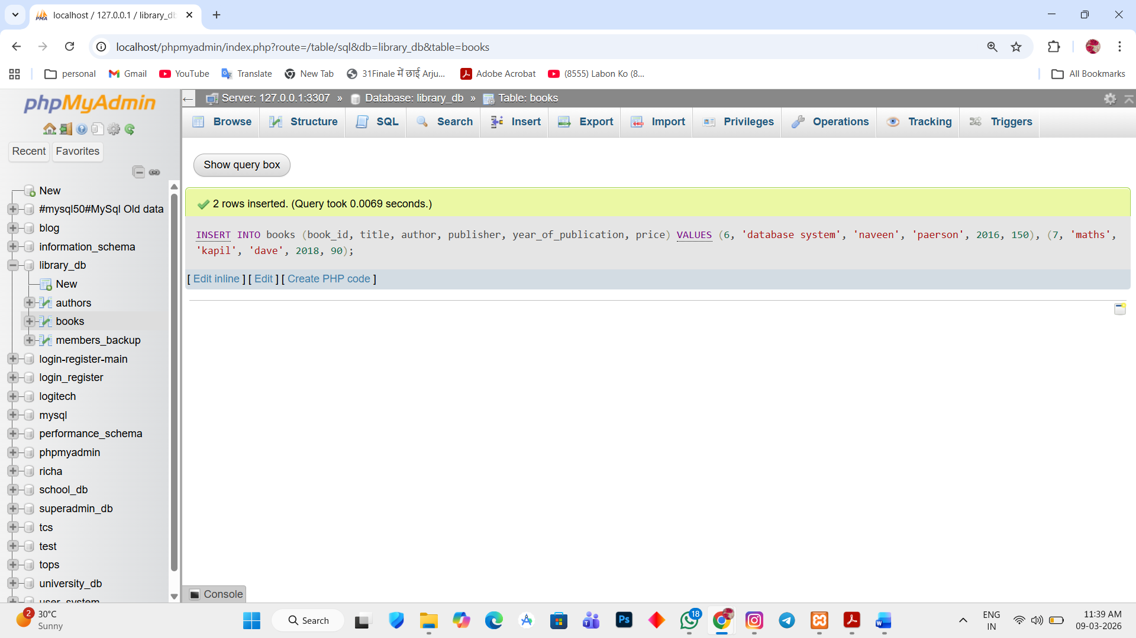

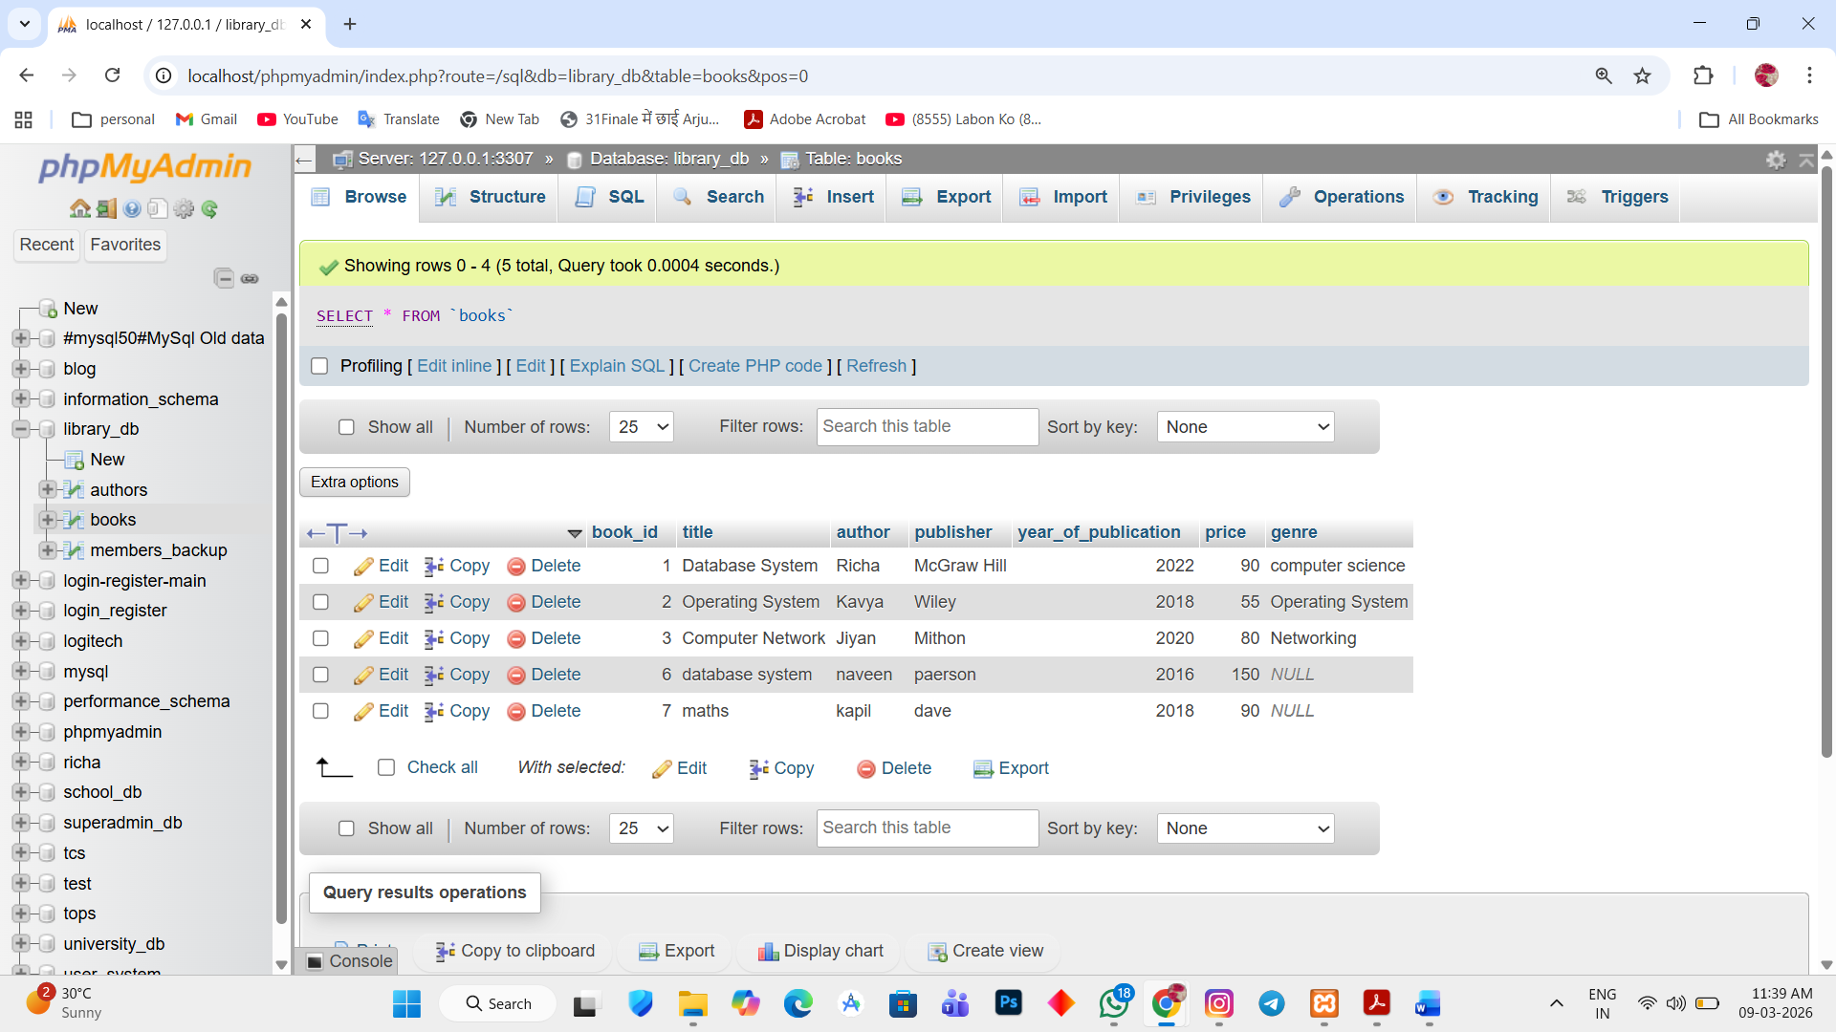

Save the changes using commit
2. COMMIT;
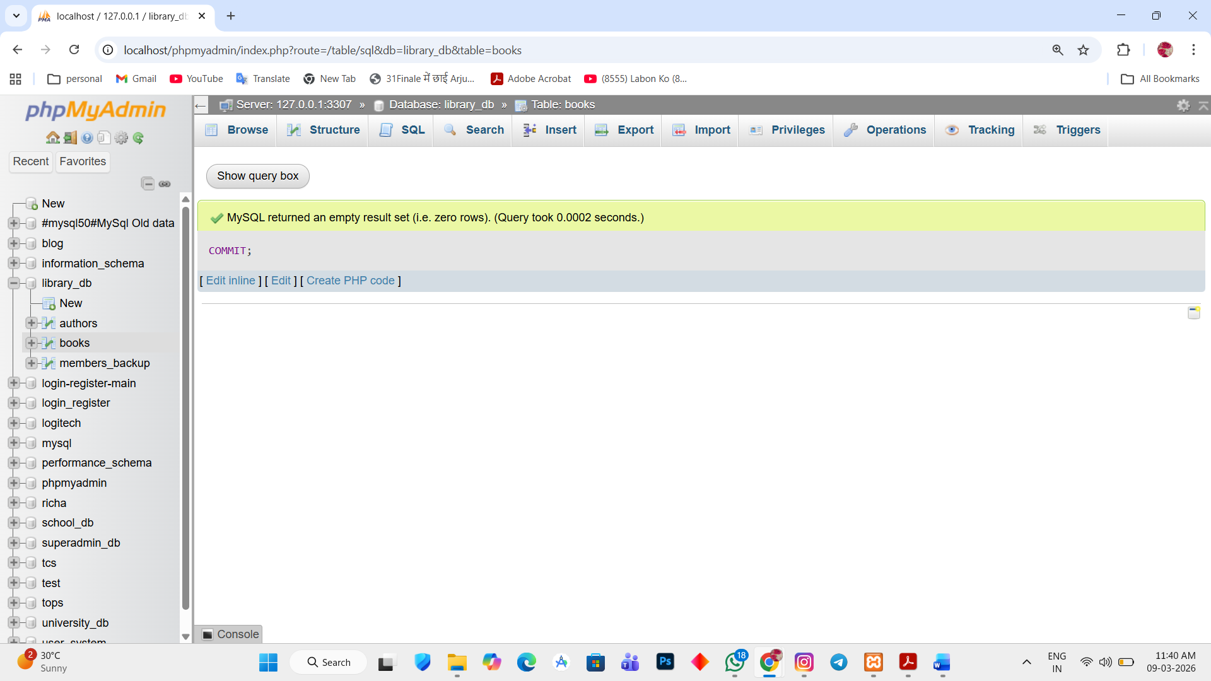

INSERT ANOTHER RECORD
3. INSERT INTO books(book_id, title, author, publisher, year_of_publication, price) VALUES (8, 'computer netwroks', 'tina', 'peri', 2015, 95);
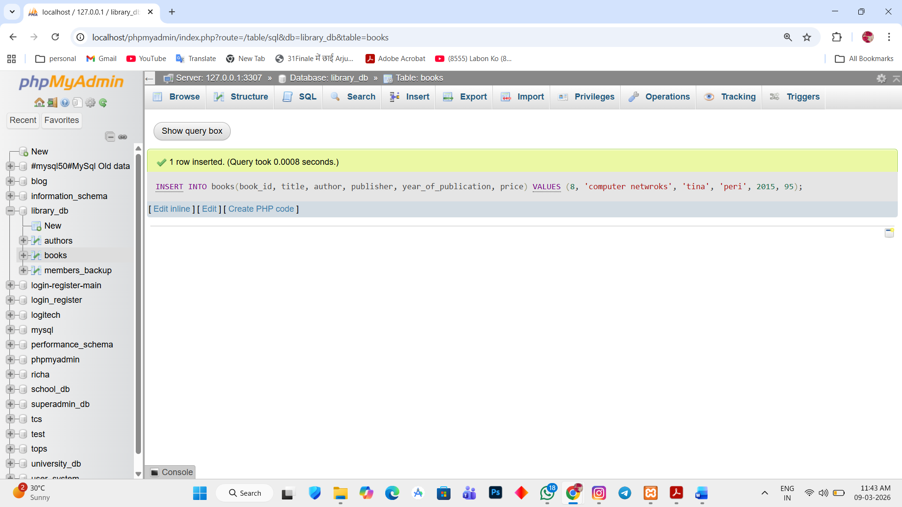

Inserting using ROLLBACK
4. ROLLBACK;

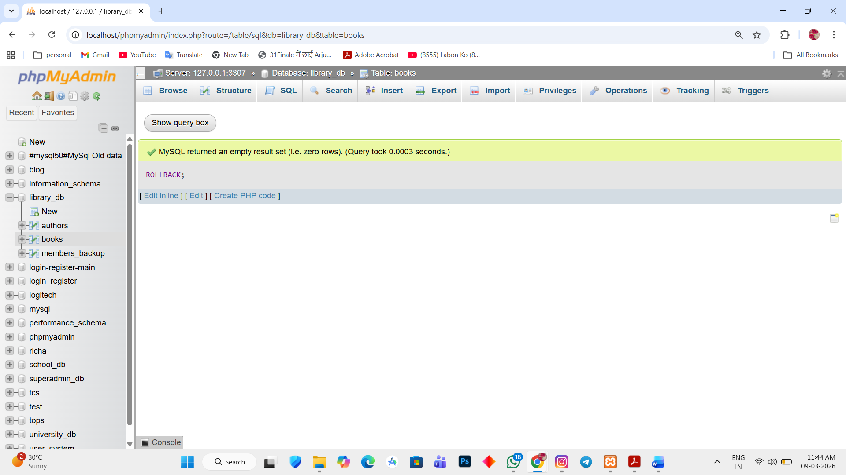

Lab 2.
Set a SAVEPOINT before making updates to the members table, performs another insertion and perform a ROLLBACK.
Ans.
1. UPDATE members SET member_name='Rahul Sharma' WHERE member_id=1;
SAVEPOINT sp1;
INSERT INTO members VALUES (6,'Amit Verma','2023-05-10','amit@example.com');
ROLLBACK TO sp1;

